Capstone Project:

Restaurant Management

System

**Simplilearn PG-BA**

**-Ajay Kalal**

**Overview and Summary**

A US celebrity chef James Oliver has his own chain of restaurants, *The Grill House*, across different cities in the USA. He wanted to put a new Restaurant Management System to track the day-to-day management of his restaurant.

Currently they have a paper-based system for the same and this has many issues. Currently the orders were taken by the waiters on paper and a paper-based bill was presented to the customers.

All the bills were entered into an excel sheet by the manager at EOD to know the total sales and item wise sales for the day. Then reports were generated on excel to know trends and details like daily, weekly, and monthly sales. Which dishes were popular and which weren’t doing so well?

Restaurants need a system that will allow them to easily update their menu. The clients currently do not have a system that recognizes the different types of users such as managers, waiters, etc. and they would like to be able to limit the access of some options of the system to certain users.

The client invited Business Analysts trained at Simplilearn to capture the requirements for the creation of this software.

**Core Concept Model**

|  |  |  |
| --- | --- | --- |
| **Need:** | **Decreased productivity due to the older paper-based management system.** | |
| **Change:** | **Is to upgrade from paper-based system to digital management system.** | |
| **Solution:** | **Development of Restaurant Management system to automate the things in Restaurant.** | |
| **Value:** | **Increase in productivity, less human errors, easy report generation etc.** | |
| **Context:** | **Old paper-based system used by the Restaurant staff lead to the development of new system with changing times.** | |
| **Stakeholder:** | External: -• Restaurant Management (Waiters, Managers) • Supplier: Payment Host • Sponsor (CEO) • Regulator | Internal: - • Project Manager • Implementation SME (Developers) • Testers • Domain SME • Operational Support |

**Problem Statement:**

*The Grill House,* restaurant chain is using old paper-based system which  
has led to decrease in productivity, human errors in data, not availability of reports and certain  
other issues in result of which restaurant revenue is decreasing and morale of working force is  
also impacted.

**Stakeholders List:**

**Internal**

|  |  |
| --- | --- |
| **Roles** | **Responsibilities** |
| Project Manager: | Project manager ensures that project is properly worked upon and entire team has all required resources needed for the project and ensures all roadblocks are minimized during the project. |
| Implementation SME: | They will be responsible for the development of RMS in JAVA environment by ensuring that all stakeholders requirements are fulfilled which will enhance the functionality of restaurant operations. |
| Operational Support: | They will assist the team with any operational hurdle during the development of system. Also, will ensure that RMS runs smooth across all locations and will oversee any maintenance when needed. |
| Testers: QA | Testers will be responsible to test the functionality of RMS and ensure that its properly functioning and improve any metric which will enhance the functions. They will also work to identify any possible risks and minimize system failures. |
| Domain SME: | These are the industry experts with best knowledge about the domain and will be taking care of all domain related support (restaurant/hospitality) and help the team to understand the industry requirements and needs. |

**Business Analyst:**

I will be responsible for mediating with internal and external stakeholders to ensure proper collaboration and fulfilment of all stakeholders needs by identifying all risks, opportunities and ways to remove the roadblocks.

**External**

|  |  |
| --- | --- |
| Restaurant Management: | These are the end users (Waiters, Managers) who will be interacting with the developed solution in daily tasks. |
| Supplier: Payment Host | Payment host will be the sole provider of online payment gateway for the convenience of online payment of customers. |
| Regulator: | Government Regulatory bodies will be ensuring that all compliance metrics and privacy related measures are taken in the new system as online payment will be accepted directly in it and may include customer confidential information. |
| Sponsor: CEO | CEO is the governing authority for whole project and the business requirements who will provide all monetary support to the team for the proper development of the RMS and approve budget for the project |

**Current As-Is State:**

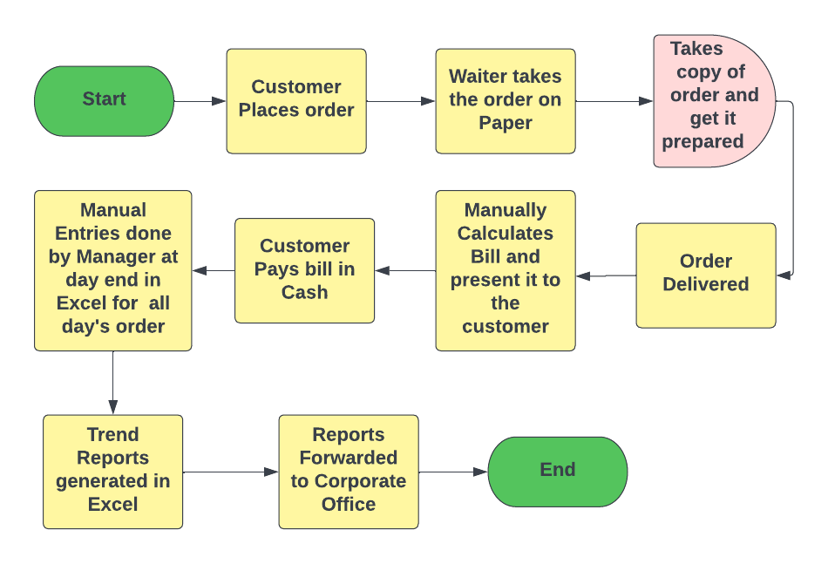

**Future State:**

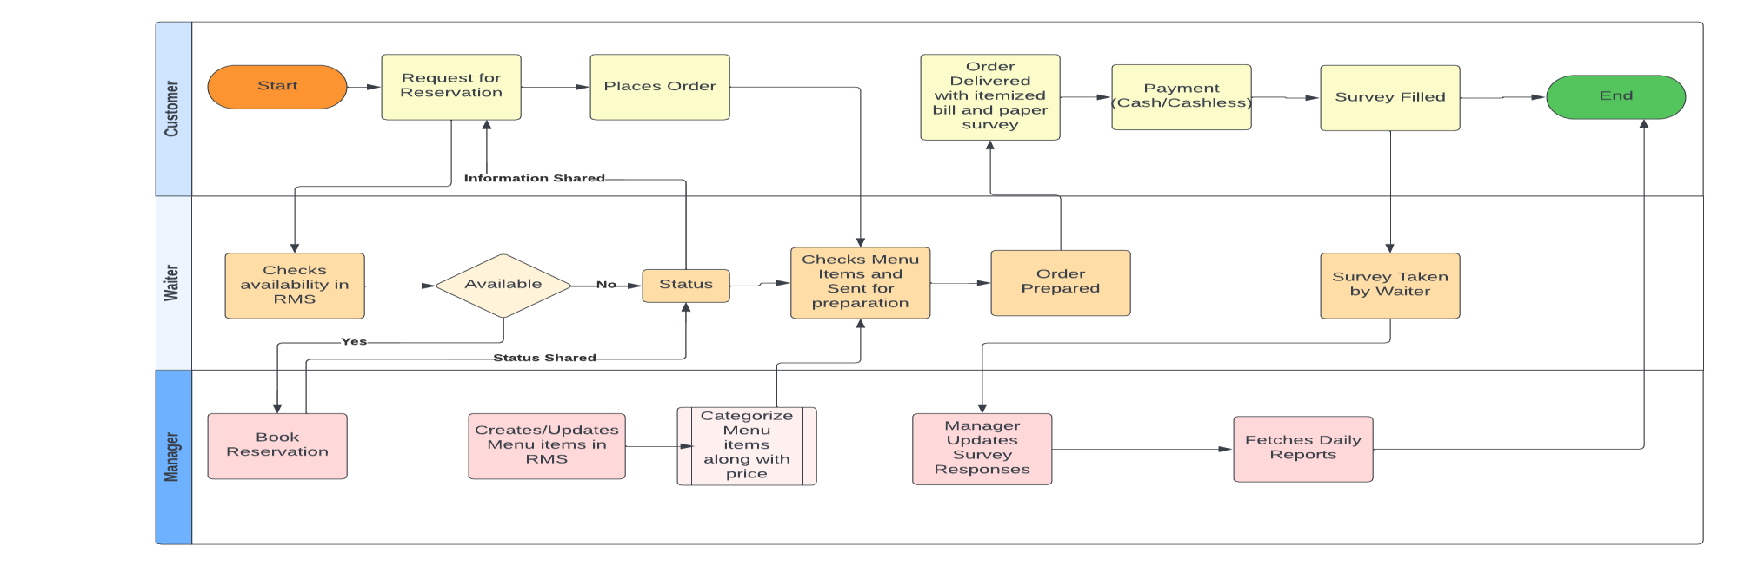

**Scope of Restaurant Management Software using Context Diagram:**

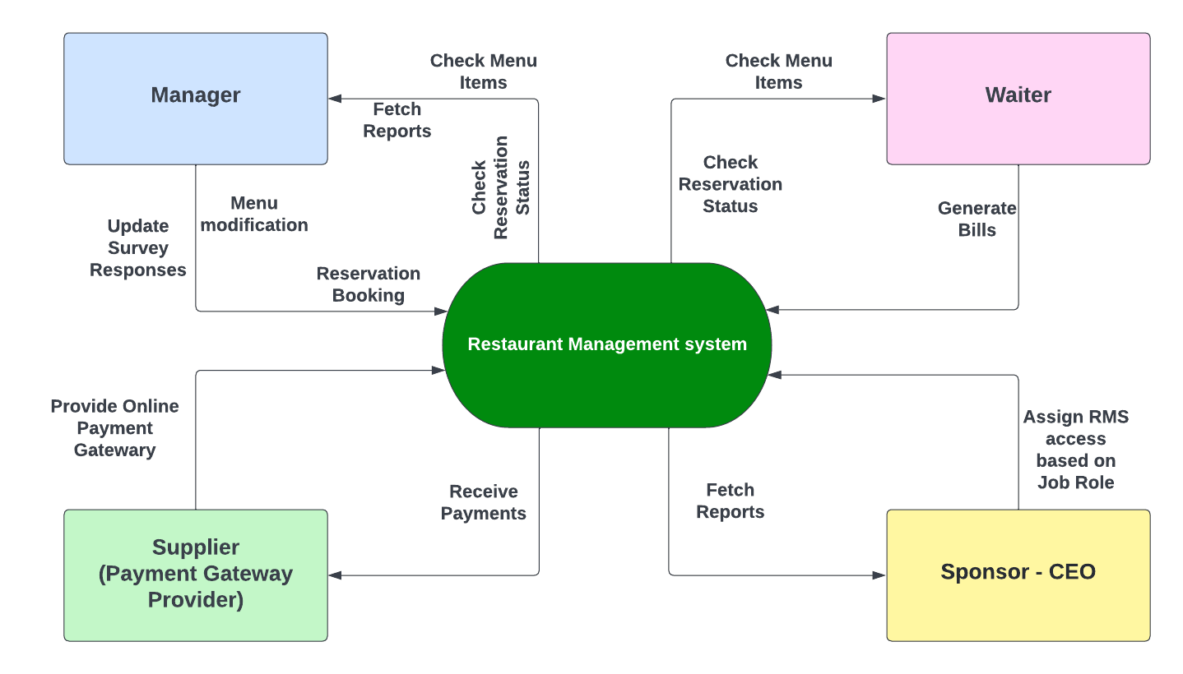

Main Features that need to be developed:  
1. Creation of Menu and able to categorize it into various sections. Also, the facility of creating/deleting/updating daily menu should be there in system.  
2. Waiters/Managers should be able to search items in menu using this facility.  
3. System should be able to reserve tables and store the reservation layout accordingly.  
4. System should be able to generate Restaurant performance reports at the end of the day  
in specified formats for easy analysis by the management.  
5. Login facility for staff should be provided in the software.  
6. System should be able to generate bill and take electronic payments using card.  
7. System should also allow the manager to submit survey responses manually.

**In-Scope and Out-of-Scope items for the Software**

|  |  |
| --- | --- |
| In-Scope | Out-of-Scope |
| • Login/logout and registration along with password change facility. • Cash or cashless payment using card. • Generation of reports. • Menu creation/updating and deletion by authorized person. • Authorized access and limitations based on job profile and authorization. • Manual entry of feedback survey responses. • Listing of menu items in categorized way along with price of each item. • Table reservation and layout information. • Electronic bill generation. • Tagging of the generated bill to the waiter generating the bill. | • Reservation can not be done by customer directly. • Payment can only be accepted in cash or via card. No other digital method is accepted. • Waiters can’t book reservation for the customer. • Limitation of feedback survey to paper-based format only |

**Requirements Classification Schema:**

Business Requirements:

• The main requirement is to develop a restaurant management system to automate the management in the restaurant and also to identify the level of access for each user based on the Job role so as to limit the functionality of the system to certain users.

Stakeholder Requirements:

Restaurant Management:

• Management wants certain reports at the end of the day. Please give the report formats for the following reports:

o Total sales of the day by dine in customers

o Total sales of the day by home delivery customers

o Total sales of the day (home delivery and dine in customers consolidated)

o Name the top 10 most sold dishes for the day

o Total sales every weekend (to be done by inputting the dates)

o Total sales every month (to be done by inputting the dates)

o List of dishes not sold in the current month (this is to phase out dishes that customers are not ordering)

o Total sales across all cities

o Total sales for each city• Managers should be able to create/update/delete menu and this functionality is limited to managers only.

• Waiters and managers should be able to search items in the menu using the search facility.

• Every waiter and manager should have access to the software.

• Only managers should be able to book reservation. Whereas The waiters shall look into the software to determine which tables need to be reserved.

CEO (James Oliver):

• James Oliver would like a feedback form (paper) to be given to every customer. This form shall capture details like name, address, mobile number, email, date of birth, anniversary dates of the customers, and their feedback. These details shall be added by the manager manually into the system.

Functional Requirements:

• System should be able to create a menu. The menu should be categorized into following sections:

o Starters

o Soups

o Main Course

o Desserts

o Drinks

• Every item in the menu stored should be categorized into any one of the above heads.

Each item should be saved in the system along with its price. For example, Green Thai Curry - price $12, Pasta – $10 and so on. This menu should be created and edited by the managers only. They should be able to add new items, delete existing items, as well as create new menus from scratch.

• Waiters and managers should be able to search items in the menu using the search facility.

• Every waiter and manager should have access to the software. Waiters shall use this system for generating the bill table wise. Every bill shall be tagged to the waiter generating it and the table number. Waiters cannot edit the menu. Waiters shall use the system only to generate bills.

• The system should be able to reserve tables. This reservation would be done by managers only. The waiters shall not seat anyone on the tables reserved. The waiters shall look into the software to determine which tables need to be reserved. The table layout is to be stored in the system.

• Functionality to generate certain reports at the end of the day.

• Login for waiters, managers, and James Oliver (CEO). Change password facility to be offered.

• Customers can pay by cash or card. There should be a payment gateway on the system.

• System should be able to generate the bill.

• Ability to update survey responses manually by the manager into the system.

Non-Functional Requirements:

Scalable: System should be scalable to new chain of restaurants if inaugurated in future.

Secure: System should be secure as to protect customer data and other information from unauthorized users.

Maintainable: System should be maintainable in times of need without any difficulty or constraints.

Useability: System should be user friendly and self-explanatory which will reduce the learning and development of new staff.

Extensibility: System should be able to adapt new changes easily when introduced and requested by the stakeholders.

Transitional Requirements:

Provide relevant training and knowledge to the staff for the newly developed tool in order to make it fully functional and make transition from paper-based tracking to automated tracking in restaurant.

System environment:

We are going to be creating and maintaining the program in Java. We chose Java because it will not change much over time, and if we make it well, there will be very little maintenance to be done on the code.

**Wireframing:**

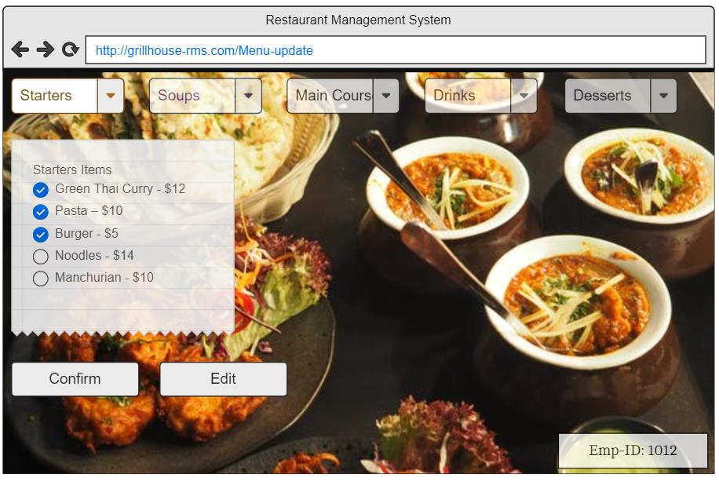

**Table Reservation Mock Screen:**

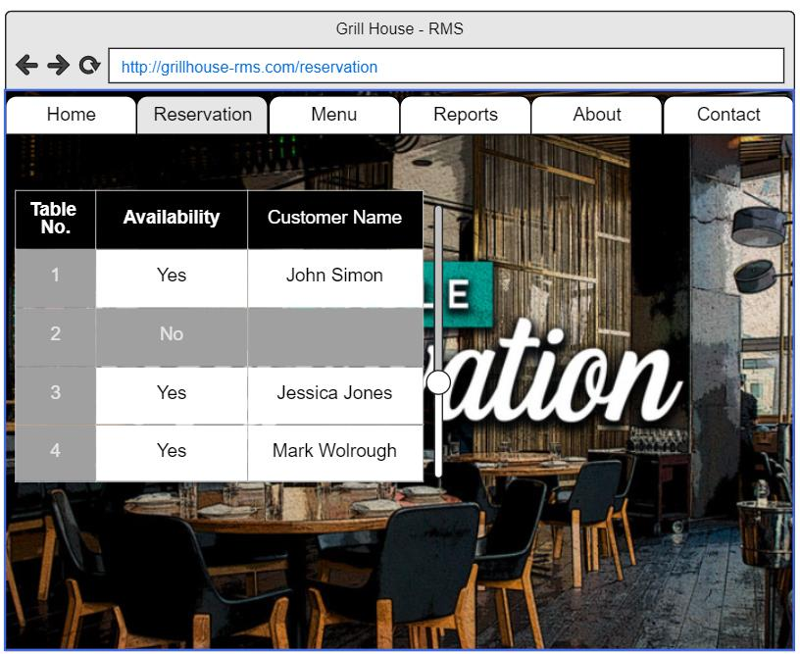

**Tableau Project Task:**

To Create a dashboard for senior management to view sales of restaurants for the last six months. Make assumptions as appropriate and create the dashboard using your own mock data.  
To `Create a dashboard to show which zone (Zone 1, 2, 3, or 4) has highest sales. Make assumptions as appropriate and create the dashboard using your own mock data.

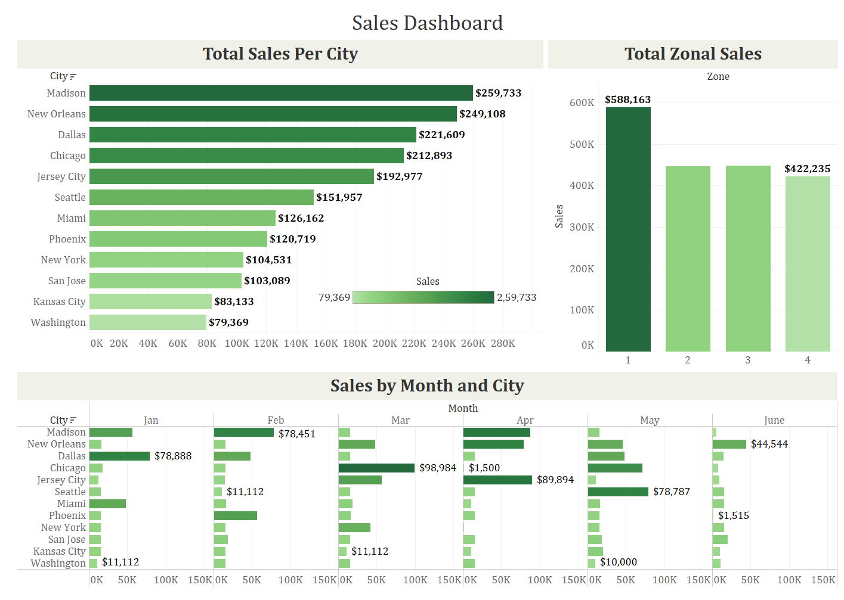

**Excel Project Task:**

Provided Dataset:

|  |  |  |  |  |  |  |  |
| --- | --- | --- | --- | --- | --- | --- | --- |
| **Restaurant ID** | **City** | **Jan** | **Feb** | **Mar** | **Apr** | **May** | **June** |
| **1200333** | **Chicago** | **$18,225.00** | **$15,184.00** | **$98,984.00** | **$1,500.00** | **$71,111.00** | **$7,889.00** |
| **1200358** | **Dallas** | **$78,888.00** | **$48,211.00** | **$15,454.00** | **$15,845.00** | **$48,211.00** | **$15,000.00** |
| **1200432** | **Jersey City** | **$12,121.00** | **$14,414.00** | **$56,451.00** | **$89,894.00** | **$11,112.00** | **$8,985.00** |
| **1200989** | **Kansas City** | **$15,455.00** | **$15,454.00** | **$11,112.00** | **$11,112.00** | **$20,000.00** | **$10,000.00** |
| **1200789** | **Madison** | **$56,451.00** | **$78,451.00** | **$15,487.00** | **$87,844.00** | **$15,845.00** | **$5,655.00** |
| **1200289** | **Miami** | **$48,211.00** | **$16,595.00** | **$18,498.00** | **$11,112.00** | **$16,595.00** | **$15,151.00** |
| **1200739** | **New Orleans** | **$16,595.00** | **$15,487.00** | **$48,211.00** | **$78,787.00** | **$45,484.00** | **$44,544.00** |
| **1200352** | **New York** | **$15,184.00** | **$15,845.00** | **$41,545.00** | **$1,622.00** | **$15,151.00** | **$15,184.00** |
| **1200498** | **Phoenix** | **$15,487.00** | **$56,451.00** | **$16,595.00** | **$15,487.00** | **$15,184.00** | **$1,515.00** |
| **1200444** | **San Jose** | **$15,454.00** | **$18,498.00** | **$15,455.00** | **$15,184.00** | **$18,498.00** | **$20,000.00** |
| **1200669** | **Seattle** | **$15,845.00** | **$11,112.00** | **$15,184.00** | **$15,184.00** | **$78,787.00** | **$15,845.00** |
| **1200888** | **Washington** | **$11,112.00** | **$15,455.00** | **$15,845.00** | **$15,845.00** | **$10,000.00** | **$11,112.00** |

Bar graph for San Jose, Madison, and New York showing the sales. Labelling the chart drawn correctly so that senior management gets a clear report of sales.

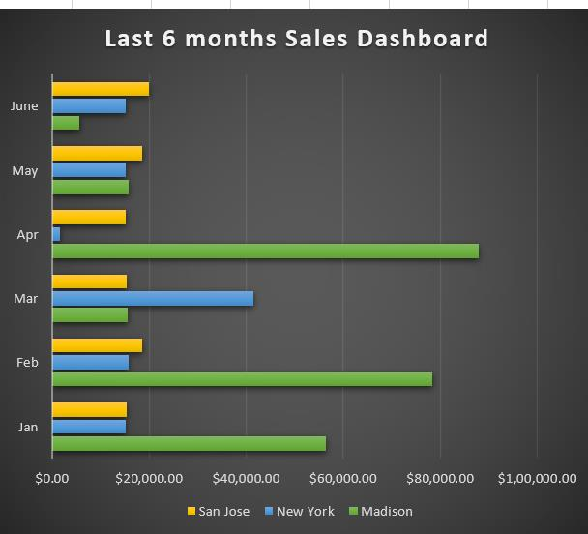

Total Sales (Madison vs New York vs San Jose):

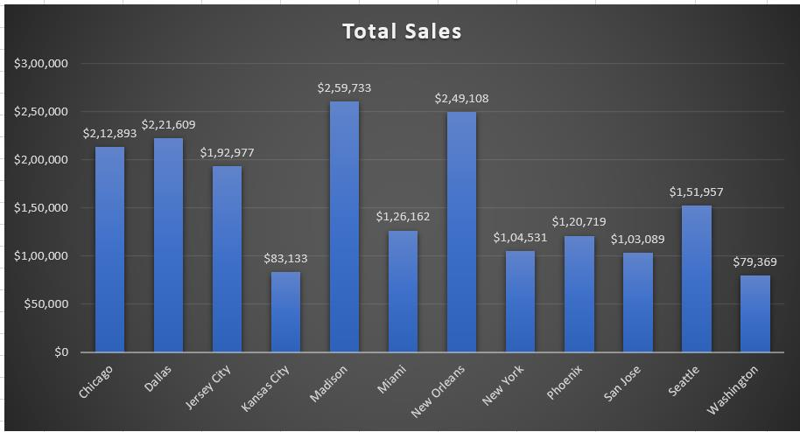

Arrange the data above in excel in an ascending and descending order for each city

